7.3.7 Editors - 3D View - Sidebar - Tool Tab - Vertex Paint Mode
Detailed table of content 1
Tools tab in Vertex Paint Mode 5
Brushes Panel 5
Browse Brush 5
Custom Icon 5
Brush Settings Panel 6
Brush Settings Panel - Color Picker Subpanel 7
Brush colors flip 7
Use unified Color 7
Brush Settings Panel - Color Palette Subpanel 8
Palette browser 8
Edit Box 8
Number of users 8
Fake User 8
Add palette 8
Remove Palette 8
Brush Settings Panel - Advanced Subpanel 9
Vertex Paint Mode - Texture Panel 9
Browse Texture to be linked 9
Texture Edit box 10
Brush Mapping 10
Brush Settings Panel - Stroke Subpanel 14
Stroke Panel with Stroke method Space 14
Stroke Panel with Stroke method Curve 15
Stroke Panel with Stroke method Line 17
Stroke Panel with Stroke method Airbrush 18
Stroke Panel with Stroke method Dots 19
Brush Settings Panel - Falloff Subpanel 20
Selecting Points 20
Adding Points 20
Navigation elements 20
Brush Settings Panel - Cursor Subpanel 22
Cursor Checkbox 22
Cursor Color 22
Falloff Opacity 22
Texture Opacity 22
Symmetry Panel 23
Mirror 23
Radial 23

Detailed table of content

Detailed table of content
Detailed table of content 1
Tools tab in Vertex Paint Mode 5
Brushes Panel 5
Browse Brush 5
Custom Icon 5
Brush Settings Panel 6
Blend 6
Radius 6
Size Pressure 7
Use Unified Radius 7
Strength 7
Size Pressure 7
Use Unified Radius 7
Brush Settings Panel - Color Picker Subpanel 7
Brush colors flip 7
Use unified Color 7
Brush Settings Panel - Color Palette Subpanel 8
Palette browser 8
Edit Box 8
Number of users 8
Fake User 8
Add palette 8
Remove Palette 8
Brush Settings Panel - Advanced Subpanel 9
Accumulate 9
Affect Alpha 9
Front Faces Only 9
Vertex Paint Mode - Texture Panel 9
Browse Texture to be linked 9
Texture Edit box 10
Brush Mapping 10
Brush Mapping with mapping method Tiled 11
Angle 11
Offset 11
Size 11
Brush Mapping with mapping method View Plane 11
Angle 11
Rake 11
Random 12
Offset 12
Size 12
Brush Mapping with mapping method 3D 12
Offset 12
Size 12
Brush Mapping with mapping method Random 12
Angle 13
Rake 13
Random 13
Offset 13
Size 13
Brush Mapping with mapping method Stencil 13
Image Aspect 13
Reset Transform 14
Angle edit box 14
Offset 14
Size 14
Brush Settings Panel - Stroke Subpanel 14
Stroke Panel with Stroke method Space 14
Spacing Edit Box 14
Dash Ratio 15
Dash Length 15
Jitter Edit Box 15
Spacing Pressure 15
Jitter Unit 15
Input Samples Edit Box 15
Stabilize Stroke 15
Smooth Stroke Radius Edit Box 15
Smooth Stroke Factor Edit Box 15
Stroke Panel with Stroke method Curve 15
Spacing Edit Box 16
Paint Curve edit box 16
Draw Curve Button 17
Jitter Edit Box 17
Jitter Pressure 17
Jitter Unit 17
Input Samples Edit Box 17
Stroke Panel with Stroke method Line 17
Spacing Edit Box 17
Jitter Edit Box 18
Jitter Pressure 18
Jitter Unit 18
Input Samples Edit Box 18
Stroke Panel with Stroke method Airbrush 18
Rate Edit Box 18
Jitter Edit Box 18
Jitter Pressure 18
Jitter Unit 18
Input Samples Edit Box 19
Stabilize Stroke 19
Smooth Stroke Radius Edit Box 19
Smooth Stroke Factor Edit Box 19
Stroke Panel with Stroke method Dots 19
Jitter Edit Box 19
Jitter Pressure 19
Jitter Unit 19
Input Samples Edit Box 19
Smooth Stroke 20
Smooth Stroke Radius Edit Box 20
Smooth Stroke Factor Edit Box 20
Brush Settings Panel - Falloff Subpanel 20
Selecting Points 20
Adding Points 20
Navigation elements 20
Zoom in and out 21
Tools 21
Reset View 21
Vector Handle 21
Auto Handle 21
Auto Clamped Handle 21
Reset Curve 21
Use Clipping 21
Delete Points 21
Curve window 21
Curve Presets 22
Falloff Shape 22
Front Face Falloff 22
Angle 22
Brush Settings Panel - Cursor Subpanel 22
Cursor Checkbox 22
Cursor Color 22
Falloff Opacity 22
Override Overlay 22
Use Cursor Overlay 22
Texture Opacity 22
Override Overlay 23
Use Cursor Overlay 23
Symmetry Panel 23
Mirror 23
Radial 23

Tools tab in Vertex Paint Mode

The Vertex paint allows you to color the vertices of a mesh.

In Vertex Paint Mode you will mainly find settings for the different brushes. General settings. And brush specific settings. This settings can be found in different panels. The brush specific options and settings are explained in the tool shelf chapter. Here we just cover the general panels.

The Vertex paint Mode just exists for Mesh objects.

Brushes Panel
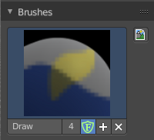
The Brush Panel contains the different Brushes and some Brush settings. Here you can choose and adjust your current active brush.

Browse Brush
The big image at the top is a dropdown box where you can choose a brush. Click at it, and you will see the different brushes. A click at one of the images will choose this brush then.
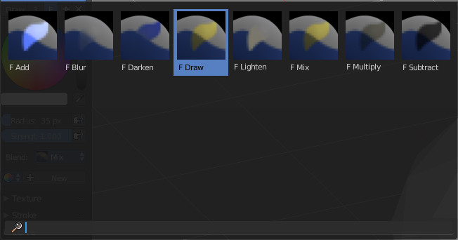
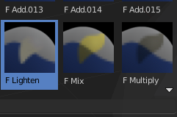
When you have added a few more brushes then the dropdown box may be more than full. You will see some little white arrows then. Either in the top left or in the bottom right corner. They indicate that some brushes are hidden before or after the current display.
To scroll to this hidden content use the mouse wheel, or the arrow up and down buttons at the keyboard.

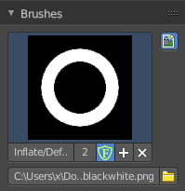
Custom Icon
The button at the right allows you to load a custom icon for your brush. It reveals a file browser below the image browser.

The edit box below the Image shows you the name of the current active brush.
The number right of it, in this case 2, indicates how much number of users ( internally ) this brush uses. This means that this data block (the brush) shares currently settings with at least one other object. Most probably the parent brush where we have created it from. Click at the value to make this brush a single user. The button will vanish then.
F set the brush to have a fake user. Zero user data-blocks are normally not saved. But sometimes you want to force the data to be kept even when the data block has no user.
The + button allows you to add a new pencil with the current settings. Note that the brushes are NOT saved when you close Bforartists. You can save them into the current blend file. Or you can save the startup file. But be careful here. This saves everything else of the current state of Bforartists too.
The X button deletes the brush as the active one. It does NOT delete it from the brushes list.

Brush Settings Panel
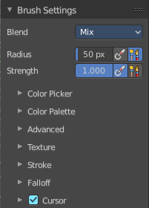
The Brush Settings Panel contains the Brush settings. The content differs, dependant of which brush you have chosen.

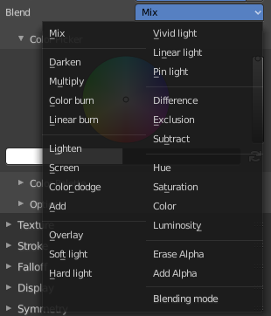
Blend
Here you can define how the stroke will blend. You can choose between various blend modes.

Radius
The Radius edit box allows you to adjust the radius of the brush. The button behind the edit box enables tablet pressure sensitivity for radius.

Size Pressure
The first button behind the edit box enables tablet pressure sensitivity for radius.

Use Unified Radius
The second button behind the edit box enables global radius size. Any modification at the radius will also modify the radius value for other paint tools.

Strength
The Strength edit box allows you to adjust the strength of the brush. The button behind the edit box enables tablet pressure sensitivity for strength.

Size Pressure
The first button behind the edit box enables tablet pressure sensitivity for radius.

Use Unified Radius
The second button behind the edit box enables global radius size. Any modification at the radius will also modify the radius value for other paint tools.

Brush Settings Panel - Color Picker Subpanel
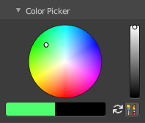
Here you can define the color for your brush.
The active color is the left one. When you click the button with the two arrows down right then you can swap the color with the secondary color. Then this secondary color becomes the primary color, and is active.

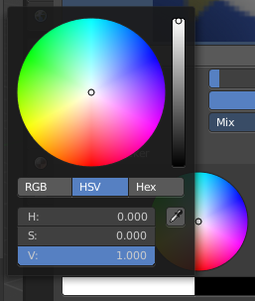
A click at one of the the color fields will open a more detailed color dialog, where you can set up the color by using rgb, hsv and hex colors and with value sliders.

Brush colors flip
Flips the primary color with the secondary color.

Use unified Color
Choose if you want to use global colors or local color just for vertex painting.

Brush Settings Panel - Color Palette Subpanel

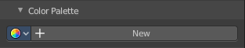
Here you can create a color palette for later reuse.
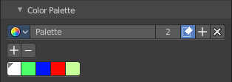
First create a new palette by clicking at New. Then adjust the color in the color picker. And then click at the add button to add this color to the palette.
To set the color picker to a palette color simply click at this palette color.
To remove a color from the palette, choose it, then click at the remove button. The active palette color that gets removed is the one with the triangle at it.
The color palette cannot be saved externally. It is part of the current blend file. You can however append color palettes from other blend files.
The elements are explained from left to right.

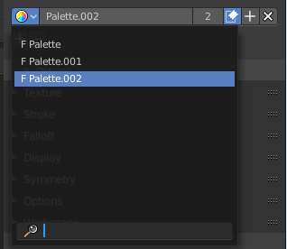
Palette browser
The button at the left opens a dropdown list where you can choose between your palettes.

Edit Box
Here you can read the name of the currently active palette. You can also rename the palette here. A click into the edit box makes the name editable.

Number of users
Here you can see how many users the palette currently has.

Fake User
Fake User sets the element to have a fake user. Zero user data-blocks are normally not saved. But sometimes you want to force the data to be kept even when the data block has no user.

Add palette
Here you can add a new palette.

Remove Palette
Clicking at this button removes the palette. Note that you need to save, close Bforartists and reload the blend file to remove the palette completely.

Brush Settings Panel - Advanced Subpanel
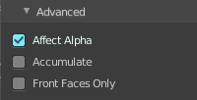
Here you can find brush specific settings.

Accumulate
Accumulate stroke daubts on top of each other.

Affect Alpha
When disabled then the alpha is locked while painting.

Front Faces Only
Paint just at faces that points forwards. Backwards pointing faces are not painted.

Vertex Paint Mode - Texture Panel

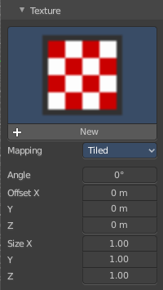
The Texture panel allows you to paint with textures. This allows you for example to grab a foto from some fish scales, and simply paint them onto the vertices by using this image as a pencil. Or as a blueprint where you calk through ( Stencil method ).

Browse Texture to be linked
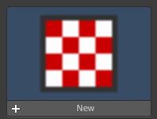
The image at the top of the panel is a image browser. Here you can choose a texture that you can choose for vertex painting then. You can also have more than one image loaded at once.

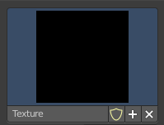
In this shot there is already a texture added. The way to add the texture here is a bit more complicated. And not done with clicking at the New button.

First click at the New button below the image. This will create a new texture slot. This slot is still empty, it displays black.

We need to load the texture in this slot. This must be done in the Properties editor in the Textures tab. And then the texture finally shows in the Texture panel in the Tool Shelf.

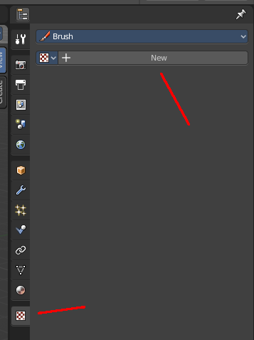
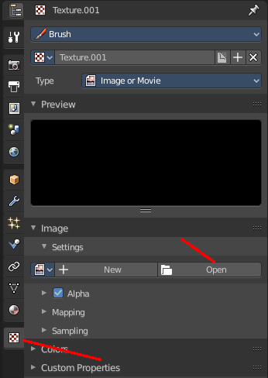
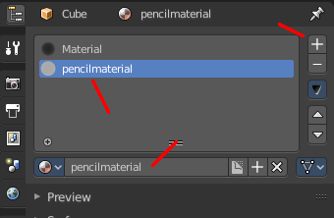
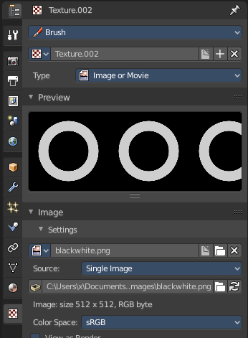

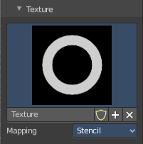
And when we switch back to the tools tab, then the texture is loaded. And we can work with this texture.

Texture Edit box
The Texture edit box is the edit box below the Image browser. When there's no image loaded then it displays the New button. When there's a image (or more) loaded, then you will see the name of the current texture.
The F button turns this texture into a data block with a fake user. Means it will exists even when there is no data connected to it anymore.
When you activate Fake User, then you may get a value in front of it, which displays how much users this data block (our texture slot) currently has.
The + Button adds another texture slot. Note that you will have to load a texture too, as explained above.
The X button deletes the texture slot.

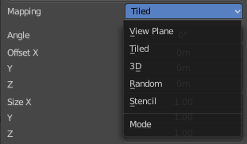
Brush Mapping
Our texture can be mapped in different methods. The Brush mapping is a dropdown box where you can choose this different brush mapping methods.
The settings vary. So we will go through them by the different brush mapping methods.

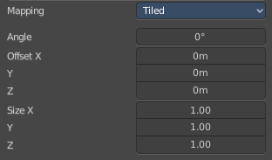
Brush Mapping with mapping method Tiled
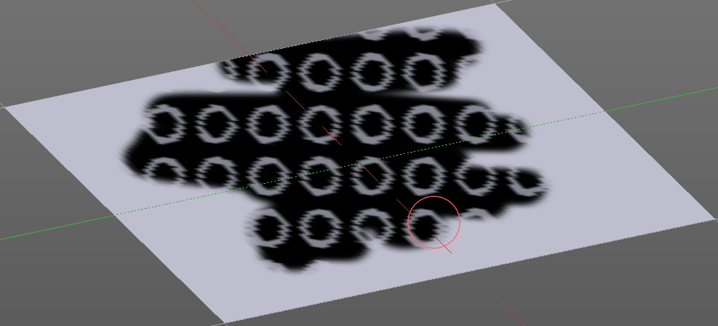
The brush mapping method Tiled tiles the brush stroke at the surface. The mapping happens from the current view. The result may be distorted when the view does not align with the surface of the object.

Angle
The angle of the brush.

Offset
The offset of the texture in the brush.

Size
The size of the texture in the brush.

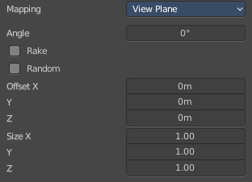
Brush Mapping with mapping method View Plane
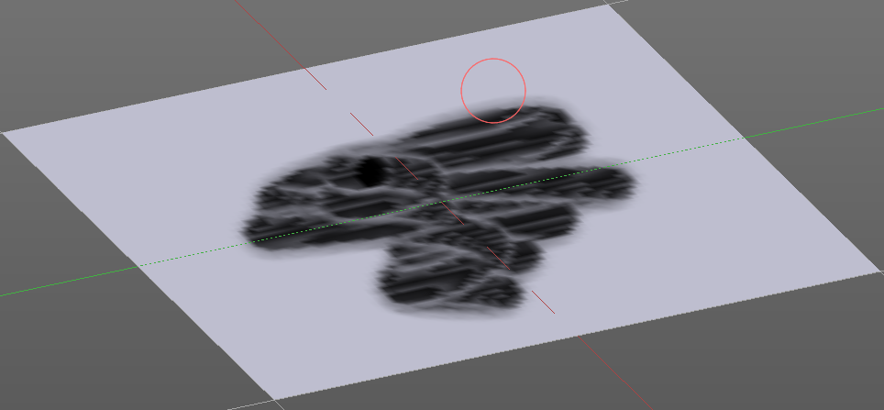
The brush mapping method View Plane simply paints onto the surface. The mapping happens from the current view. The result may be distorted when the view does not align with the surface of the object.

Angle
The angle of the brush.

Rake
The angle follows the direction of the brush stroke.

Random
The brush angle gets set random.

Offset
The offset of the texture in the brush.

Size
The size of the texture in the brush.

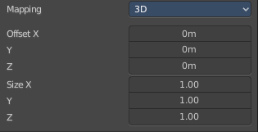
Brush Mapping with mapping method 3D
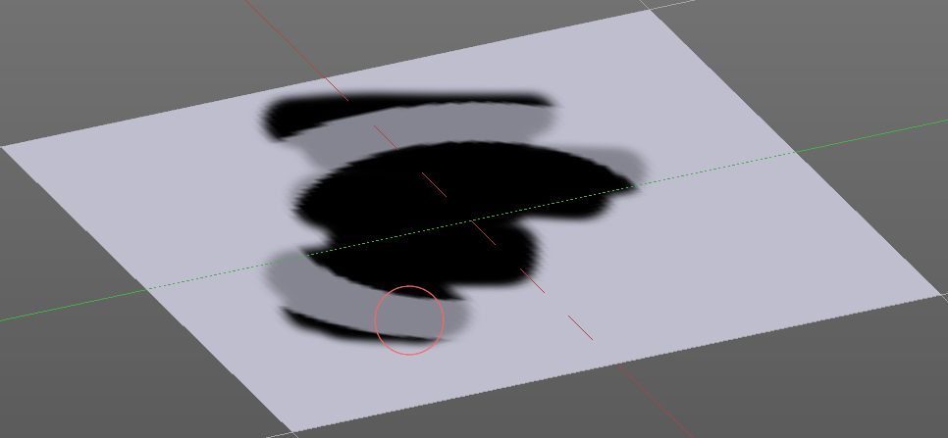
The brush mapping method 3D paints the texture at the surface, by tiling it 1/1 at the object surface.

Offset
The offset of the texture in the brush.

Size
The size of the texture in the brush.

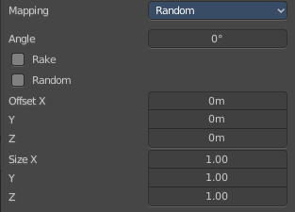
Brush Mapping with mapping method Random
The brush mapping method Random paints onto the surface, and randomizes the texture position in the brush while that. The mapping happens from the current view. The result may be distorted when the view does not align with the surface of the object.

Angle
The angle of the brush.

Rake
The angle follows the direction of the brush stroke.

Random
The brush angle gets set random.

Offset
The offset of the texture in the brush.

Size
The size of the texture in the brush.

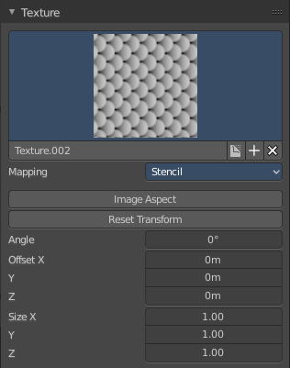
Brush Mapping with mapping method Stencil
The former methods uses the textures for the brush. The method Stencil works different. You have your texture displayed in the workspace above the object, and you paint this texture onto your object with your pencil strokes.
Note that the texture in the 3d space is just visible when you are with the mouse over the viewport. It gets by default displayed down left. You have to position it where you need it. See Brush menu, Stencil Texture controls.
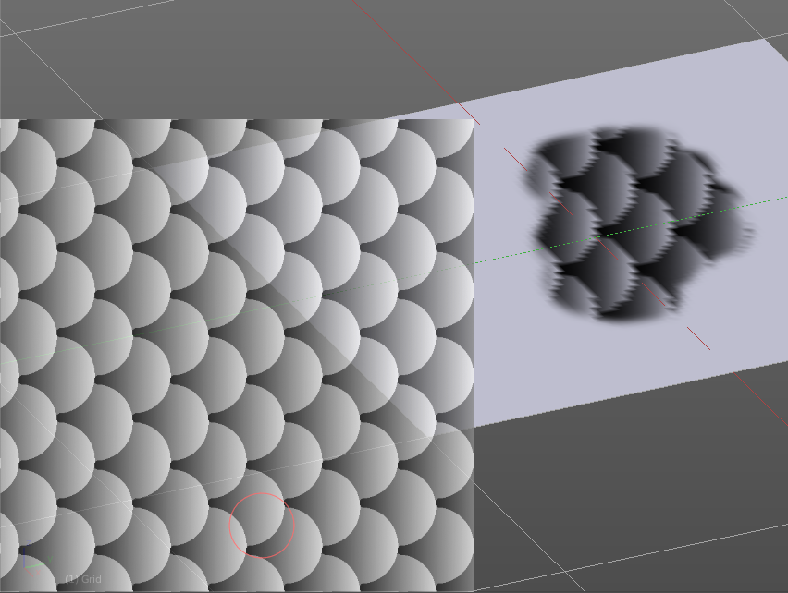
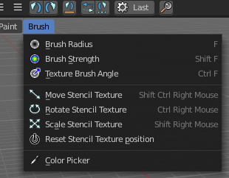

Image Aspect
Adjust the stencil size to fit to the image aspect ratio.

Reset Transform
Resets all transforms.

Angle edit box
Here you can adjust the angle of the brush. The button at the end allows you to set the radius by dragging the mouse. This should be done in the viewport and with the hotkey. This button is just a visible reminder.

Offset
Fine tune the offset of the texture in the brush.

Size
Fine tune the size of the texture in the brush.

Brush Settings Panel - Stroke Subpanel

The Stroke panel contains settings to influence the behaviour of the brush stroke. There are various stroke methods available. We will go through them one by one.

Stroke Panel with Stroke method Space
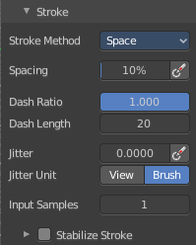
This is the default Stroke method. The sculpt stroke gets added continuously with given settings.
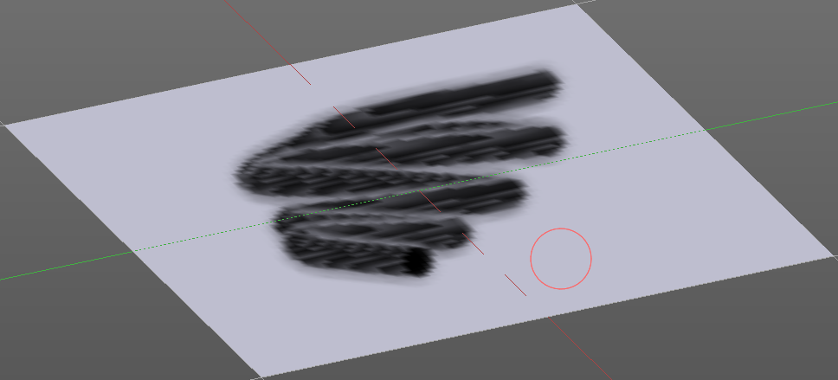

Spacing Edit Box
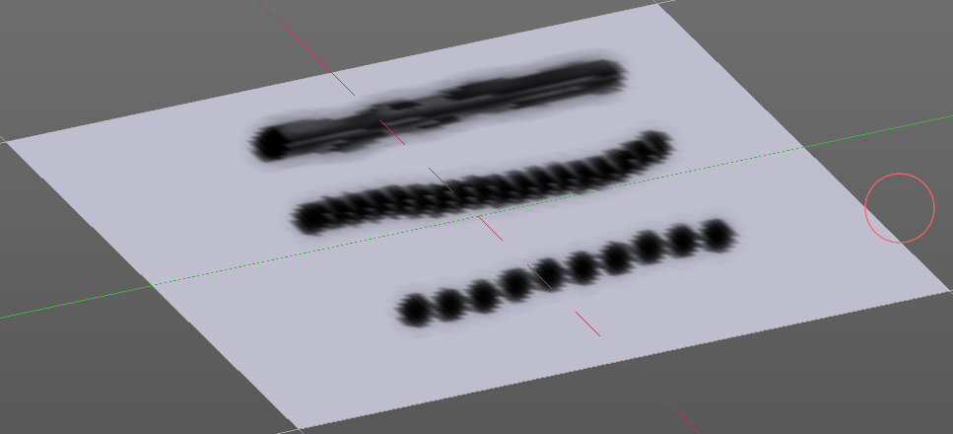
The sculpt drawing happens by mapping the pencil onto the mouse position. And when you move the mouse then the next mapping happens. Here you can adjust the spacing after what mouse movement the next mapping should happen. The lower the value, the lower the distance between the single dots.
The icon behind the edit box enables tablet pressure sensitivity for tablets.

Dash Ratio
Ratio of samples in a cycle that the brush is covering.

Dash Length
Length of a dash cycle measured in stroke samples.

Jitter Edit Box
Here you can add Jitter to the brush while painting.

Spacing Pressure
The icon behind the edit box enables tablet pressure sensitivity for tablets.

Jitter Unit
Jitter in screen space, or relative to the brush size.

Input Samples Edit Box
Average multiple input samples together to smooth the brush stroke.

Stabilize Stroke
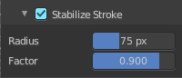
The brush lags behind the mouse position, and produces a much smoother stroke by that. The Smooth Stroke relatet settings are hidden as long as Smooth Stroke is not activated.

Smooth Stroke Radius Edit Box
Is just active when Smooth Stroke is activated. Here you can adjust the radius of the smoothing.

Smooth Stroke Factor Edit Box
Is just active when Smooth Stroke is activated. Here you can adjust the factor of the smoothing.

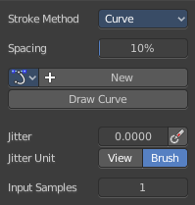
Stroke Panel with Stroke method Curve
The Stroke method curve doesn't simply influence the way how the stroke is painted. It is a special method. First you draw a curve object by holding down ctrl and clicking with left mouse button. Then you tweak the curve. You can click at the curve point, and drag out handlers to make the curve points smoooth.
Then you hit the Draw Curve button. And the curve gets drawn onto the surface.

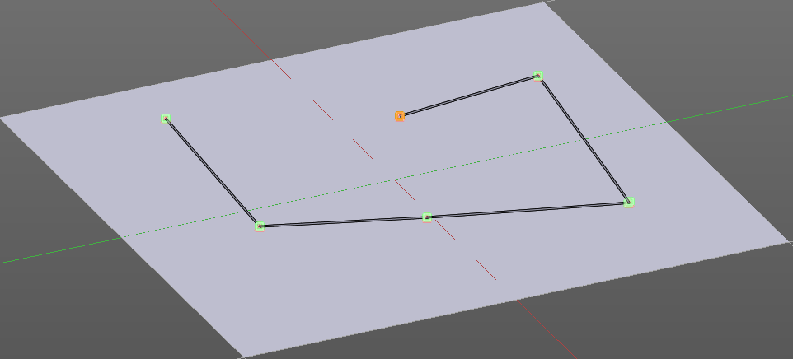
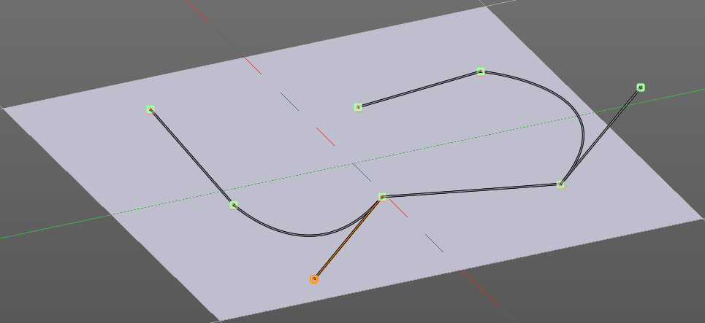
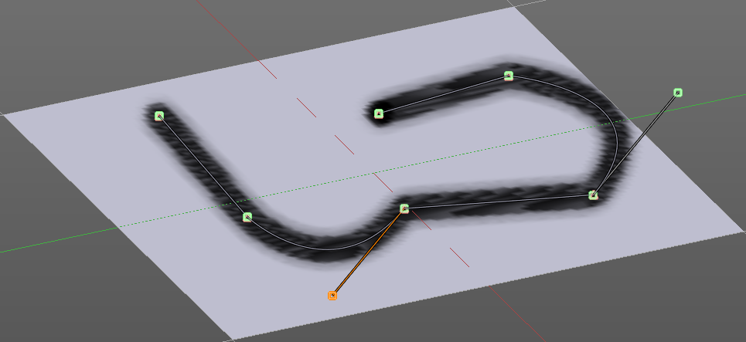

Spacing Edit Box
The drawing happens by mapping the pencil onto the mouse position. And when you move the mouse then the next mapping happens. Here you can adjust the spacing after what mouse movement the next mapping should happen. The lower the value, the lower the distance between the single dots.
The icon behind the edit box enables tablet pressure sensitivity for tablets.

Paint Curve edit box
Here you set the active curve.
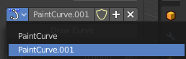
The first element is a dropdown box where you will find your curves objects. You can have more than one.
The second element is the edit box that displays the active curve.
The shield icon set the brush to have a fake user. Zero user data-blocks are normally not saved. But sometimes you want to force the data to be kept even when the data block has no user.
The + button allows you to add a new pencil with the current settings. Note that the brushes are NOT saved when you close Bforartists. You can save them into the current blend file. Or you can save the startup file. But be careful here. This saves everything else of the current state of Bforartists too.
The X button deletes the brush as the active one. It does NOT delete it from the brushes list.

Draw Curve Button
A click at it to turns the curve into a sculpt stroke.

Jitter Edit Box
Here you can add Jitter to the brush while painting.

Jitter Pressure
The icon behind the edit box enables tablet pressure sensitivity for tablets.

Jitter Unit
Jitter in screen space, or relative to the brush size.

Input Samples Edit Box
Average multiple input samples together to smooth the brush stroke.

Stroke Panel with Stroke method Line
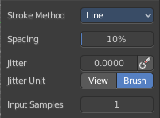
With Stroke method line you draw a line between a starting point and a endpoint. And when you release the mouse then the line gets sculpted.

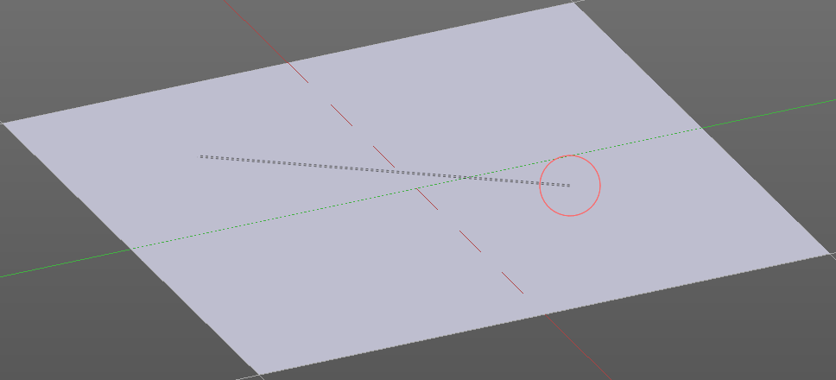
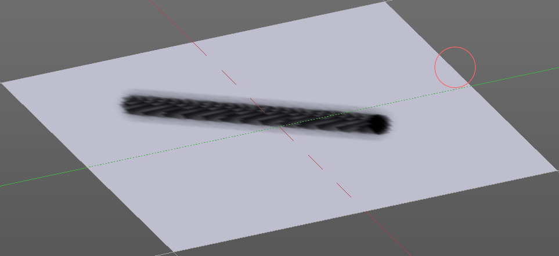
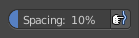

Spacing Edit Box
The sculpt drawing happens by mapping the pencil onto the mouse position. And when you move the mouse then the next mapping happens. Here you can adjust the spacing after what mouse movement the next mapping should happen. The lower the value, the lower the distance between the single dots.
The icon behind the edit box enables tablet pressure sensitivity for tablets.

Jitter Edit Box
Here you can add Jitter to the brush while painting.

Jitter Pressure
The icon behind the edit box enables tablet pressure sensitivity for tablets.

Jitter Unit
Jitter in screen space, or relative to the brush size.

Input Samples Edit Box
Average multiple input samples together to smooth the brush stroke.

Stroke Panel with Stroke method Airbrush
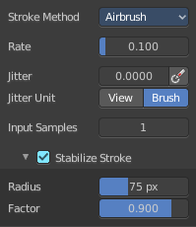
The stroke acts like an airbrush pencil. The dots gets placed randomly.
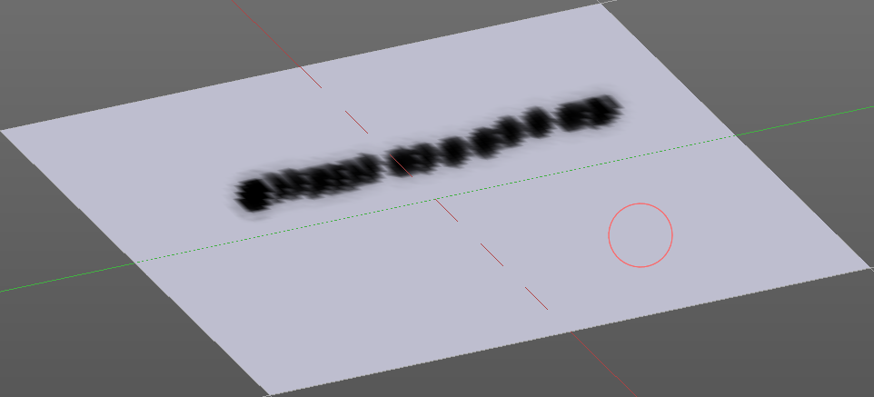

Rate Edit Box
Here you can define the rate of the drawing.

Jitter Edit Box
Here you can add Jitter to the brush while painting.

Jitter Pressure
The icon behind the edit box enables tablet pressure sensitivity for tablets.

Jitter Unit
Jitter in screen space, or relative to the brush size.

Input Samples Edit Box
Average multiple input samples together to smooth the brush stroke.

Stabilize Stroke
The brush lags behind the mouse position, and produces a much smoother stroke by that.

Smooth Stroke Radius Edit Box
Is just active when Smooth Stroke is activated. Here you can adjust the radius of the smoothing.

Smooth Stroke Factor Edit Box
Is just active when Smooth Stroke is activated. Here you can adjust the factor of the smoothing.

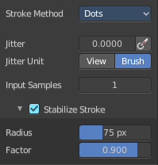
Stroke Panel with Stroke method Dots
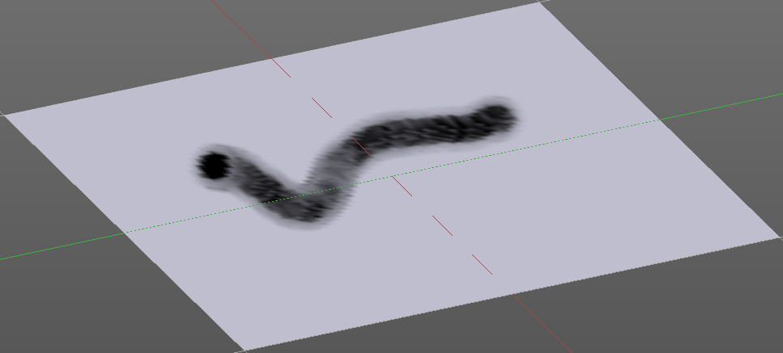
The stroke method Dots draws dots of the pencil onto the surface. The mapping happens from the current view. Means you will get distortions when your view is not aligned with the surface of the object.

Jitter Edit Box
Here you can add Jitter to the brush while painting.

Jitter Pressure
The icon behind the edit box enables tablet pressure sensitivity for tablets.

Jitter Unit
Jitter in screen space, or relative to the brush size.

Input Samples Edit Box
Average multiple input samples together to smooth the brush stroke.

Smooth Stroke
The brush lags behind the mouse position, and produces a much smoother stroke by that.

Smooth Stroke Radius Edit Box
Is just active when Smooth Stroke is activated. Here you can adjust the radius of the smoothing.

Smooth Stroke Factor Edit Box
Is just active when Smooth Stroke is activated. Here you can adjust the factor of the smoothing.

Brush Settings Panel - Falloff Subpanel
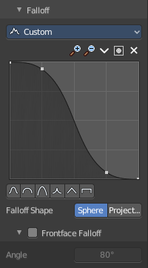
The curve panel allows you to define different fallofs methods for the border of the brush.


Selecting Points
You can select curve points. This reveals two edit boxes for the x and y coordinate of this point.
Selected points can be moved around. Left click at them, hold the mouse button down and move them to a new location.


Adding Points
You can add new curve points by simply left clicking at the curve. Move the mouse to position them where you need it.

Navigation elements
The navigation elements at the top are described from left to right.

Zoom in and out
The two buttons with the magnifying glass at it zooms in and out in the curve window.

Tools
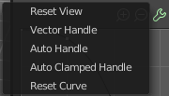
Tools is a menu where you can find some cuve related tools.

Reset View
Resets the curve windows zoom.

Vector Handle
Set handle type to Vector.

Auto Handle
Set handle type to Auto.

Auto Clamped Handle
Set handle type to Auto Clamped.

Reset Curve
Resets the curve to the initial shape.


Use Clipping
Clipping options. Here you can set up clipping for the stroke.

Delete Points
Deletes selected curve points.

Curve window
Here you can tweak and adjust the falloff curve by clicking at a curve point and dragging it around.
Double click adds a new point.
Holding down ctrl activates temporary snapping.
Holding down shift enables slower movement, which allows more accurate setting.


Curve Presets
Here you can find some predefined curve presets.

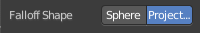
Falloff Shape
Use projected or spherical falloff.

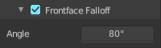
Front Face Falloff
Blend Brush influence, dependant by how much they face the front.

Angle
Here you can adjust the angle.

Brush Settings Panel - Cursor Subpanel

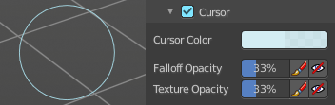
Here you can adjust the color and appearance of the brush cursor to custom values.

Cursor Checkbox
Activate the custom settings.

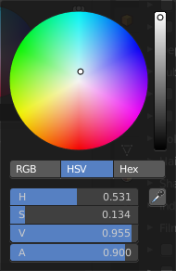
Cursor Color
Here you can choose another color for the brush cursor. Double clicking at the color field will open a color picker.

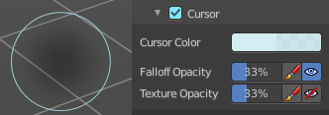
Falloff Opacity
You can turn on the cursor overlay with the eye button at the end. The falloff opacity slider allows you to adjust the opacity of this cursor overlay.

Override Overlay
Hide the Cursor Overlay when painting.

Use Cursor Overlay
Turn on Cursor Overlay.

Texture Opacity
This is for the case when you paint with a texture brush. You can turn on the Texture overlay with the eye button at the end. The falloff opacity slider allows you to adjust the opacity of this cursor overlay.

Override Overlay
Hide the Texture Overlay when painting.

Use Cursor Overlay
Turn on Texture Overlay.

Symmetry Panel
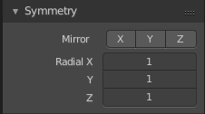

Mirror
Mirror along given axis.
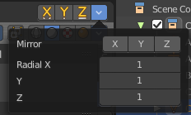
The same buttons plus the whole Symmetry Lock Panel as a dropdown menu can also be found in the tool settings bar as icon buttons. This allows quicker access and better

Radial
Tiling. The number of times to repeat the strokes across the surface.

